BIOC 455
Lecture # 26– Catecholamines
Lecturer: Dr. Marco Leyton – Mon. March 14th, 2007

NOTE: This NTC is meant to be used as a study aid to supplement your own class notes. Hence, not all of the text or diagrams contained in the lecture slides will be reproduced here.

Please send any comments or questions about NTCs to either Wanda or James through e-mail at u3.represent@gmail.com .

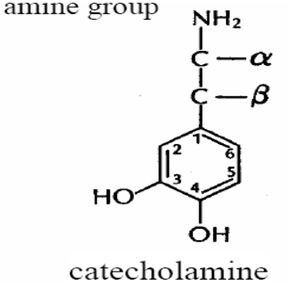

Catecholamines (slides 2-3)
There are 3 main types of catecholamines, Dopamine (DA), Norepinephrine (NE) and Epinephrine (E). They are all similar in structure having a benzene ring with two hydroxyl substituents as well as an amine group. (don’t need to memorize structure)
DA and NE were not seen as neurotransmitters but as precursors for Epinephrine until the 1950s when their locations were mapped out. They were shown to have a different anatomical distribution, therefore different functional significance.

Human Dopamine System (slide 5)
There are 4 major DA pathways in the brain. Two pathways act through the substantia nigra, on the upper brain stem which has an important role in the initiation of movement. The substantia nigra contains DA cell bodies and projects into the dorsal striatum.
The obstruction of DA cells in the striatum leads to Parkinson’s disease which makes it hard to initiate movement. Parkinson’s is treated by L-DOPA, a DA precursor.
The other DA pathways act through the Ventral Tegmented Area (VTA) which is beside the Substantia Nigra. The VTA projects into the ventral striatum and the Frontal Lobe.
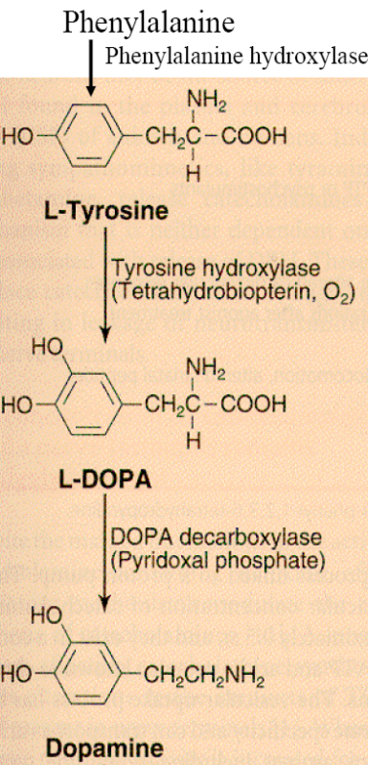
Increased DA in the frontal lobe inhibits activity in the striatum.

Rat DA Anatomy: same basic features as human (slides 6-7)

NE System (slide 8-9)
Most cells in this system are ascending (have a more diffuse distribution) to 1) cortex and subcortical structures and 2) to striatum (dense projections, not seen in rat)

Epinephrine System (slide 10)
Very little epinephrine found in brain and what it does in the brain is not well studied

DA Synthesis (slide 11)
Synthesized from essential AA Phe. Phe hydroxylase adds OH to make L-Tyr. Tyr hydroxylase (rate limiting step) adds OH to make L-DA. Activity of Tyr hydroxylase varies with respect to O₂, low O₂ = low DA synthesis. Its activity also varies wrt BH₄, DA competes for binding site on enzyme, regulatory feedback. Tyr hydroxylase usually 75% saturated by Tyr.
In human brain, DA broken down by Monoamine oxidase B.
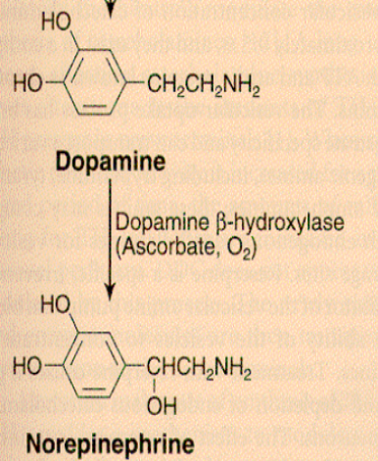

Norepinephrine Synthesis (slide 12)
NE neurons have Dopamine Beta-hydroxylase which hydroxylates DA forming NE.
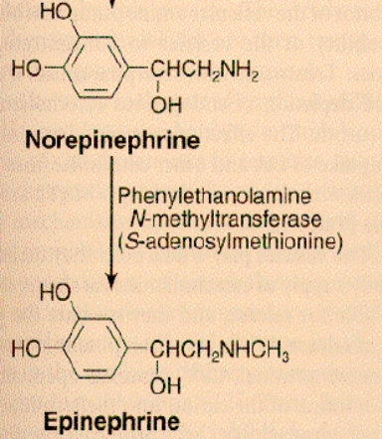
Epinephrine Synthesis (slide 13)
SAM adds methyl group to NE forming epinephrine.

DA Catabolism (slide 15)
If DA doesn’t get into a vesicle quickly enough, it is degraded into DOPAC by Monoamine Oxidase (MAO).

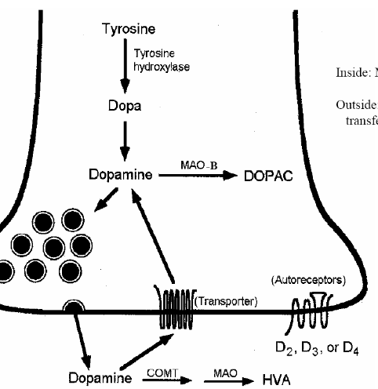
DA is released by vesicles into the synaptic cleft where it becomes vulnerable to the enzyme COMT, whose product can be further broken down into HVA by MAO.
Non-degraded DA is reuptaken by DA transporters where it is degraded or goes into a vesicle.
DA transporters are actually on the edge of the synaptic cleft (not in the middle as shown on diagram)

Prefrontal Cortex (slide 16)
In the prefrontal cortex, DA catabolism is different. There are few DA transporters so DA is reuptaken by NE transporters showing that transporters have less specificity than previously thought.
DA transporters are preferential to DA but not exclusive, likewise for NE.

NE Catabolism (slide 17)
(don’t need to memorize everything)
Broken down in 2 main ways: 1) Substrate for COMT then broken down by MAO
2) Substrate for MAO then broken down by COMT
COMT – main action is in frontal cortex

DA Receptors (slide 18-20)
2 receptor families: D1 (D1 & D5 type) & D2 (D2, D3 & D4 type)
D1: widely distributed in cortex and subcortical regions, not in substantia nigra
D2: Primarily in basal ganglia

D2 receptors: present in postsynaptic membrane (downstream effect) and presynaptic cell but have higher affinity pre-synaptically, functioning as autoreceptors.
Stimulation leads to activation of adenylate cyclase
D1 receptors: only present on post-synaptic cells
Stimulation leads to inhibition of adenylate cyclase

Alpha Adrenergic Receptors (slide 21)
Alpha 1: Respond to both epinephrine and NE
Likely G-protein linked, primarily postsynaptic
Alpha 2: Pre & Post synaptic

Beta Adrenergic Receptors (slide 22)
G-protein linked, primarily post synaptic, increases cAMP levels
Blocked by Beta-blockers which are used to calm nerve/ steady self physically

Beta 2 Receptor Internalization (slide 23-24)
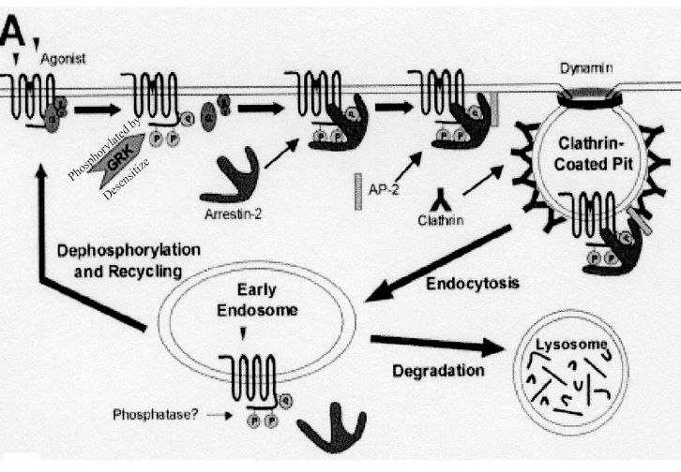
Agonist stimulates the receptor, leading to the receptor’s phosphorylation by G-protein related kinases, desensitizing the receptor to the ligand
Arrestins bind the receptor and further desensitizes it then drags it into the neuron
Receptor is brought into a clathrin-coated pit where it is either degraded & used as building blocks or it is dephosphorylated & reused on the membrane
Addition of GRKs or arrestins causes receptor internalization

DA Tracers (slide 25)
- Give measure of DA synthesis
- Bind to DA transporters
- Bind preferentially to D1R or D2R
Most DA is found in the striatum, where 80% of receptors project

